# Apply filters to SQL queries

## Project description

SQL allows the user to filter through company data to look for specific data of interest. This includes login attempts, and data about employees.

## Retrieve after hours failed login attempts

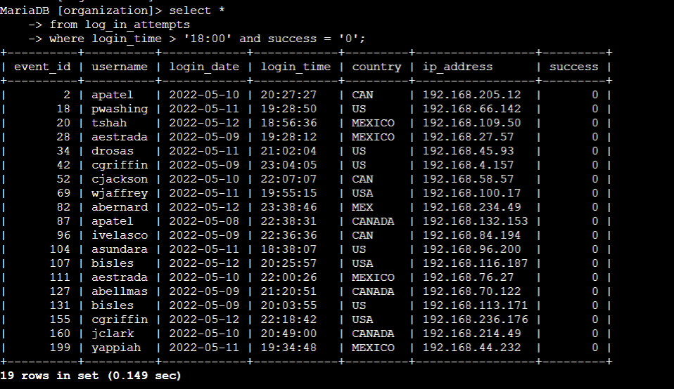

Selected all columns from log_in_attempts table. Specified to filter data so that login_time is after 6, and the login attempt failed (‘0’ means login attempt was false/failed).

## Retrieve login attempts on specific dates

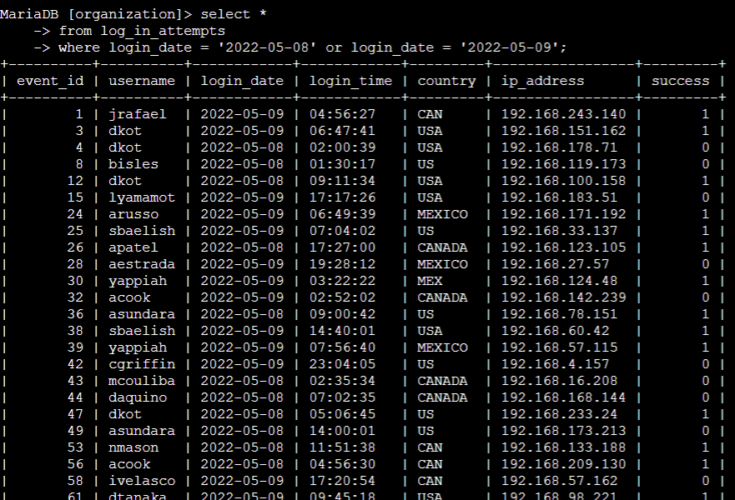

Specified to look for when login_date was ‘2022-05-08’ or ‘2022-05-09’. This means that it will look for both conditions and return whatever data fits either one of them.

## Retrieve login attempts outside of Mexico

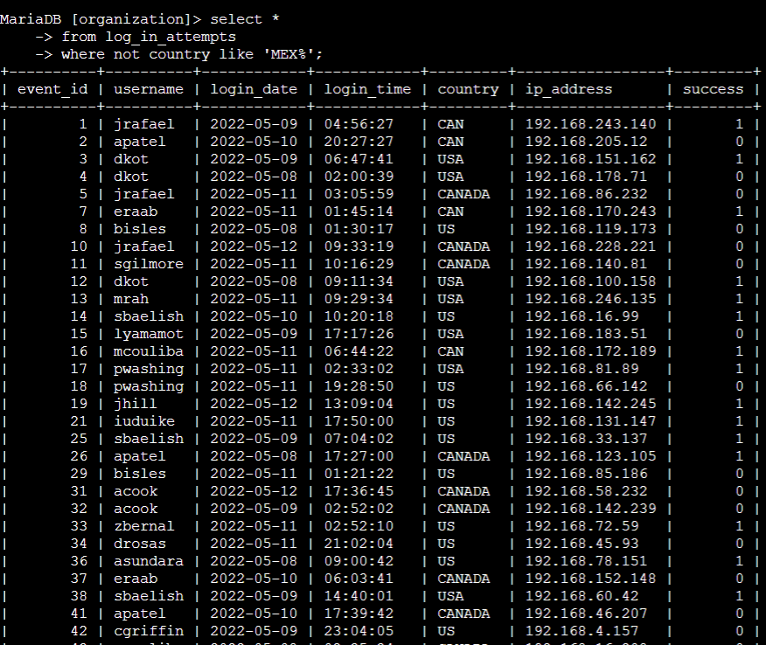

Filters for data where the country column does not include the ‘MEX’ sequence of characters within it.

## Retrieve employees in Marketing

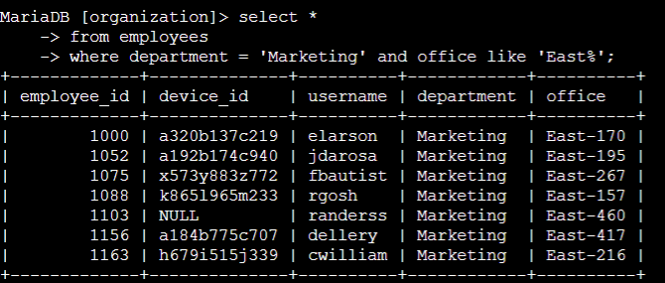

Filters for data in the employees table where the department is ‘Marketing’ and the office includes the sequence of characters ‘East’ in it.

## Retrieve employees in Finance or Sales

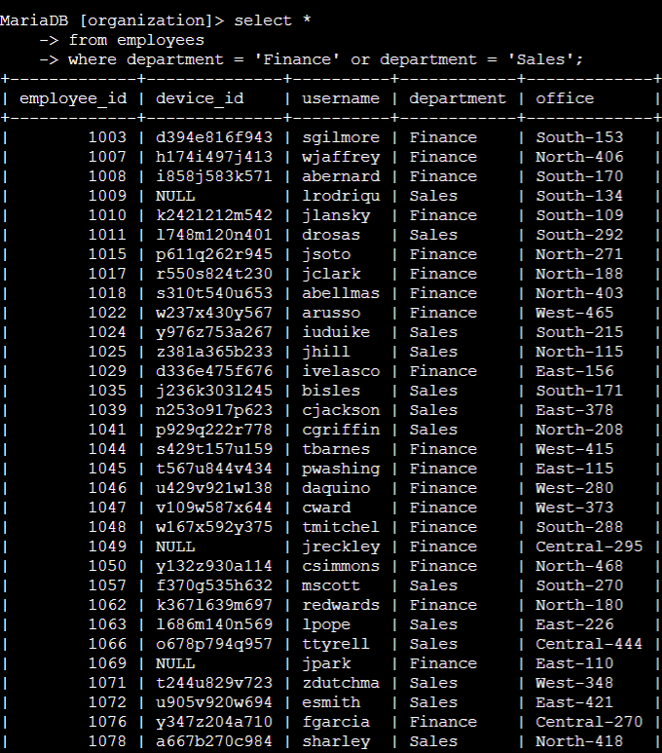

Filters for data from employees table which has their department either in Sales or Finance.

## Retrieve all employees not in IT

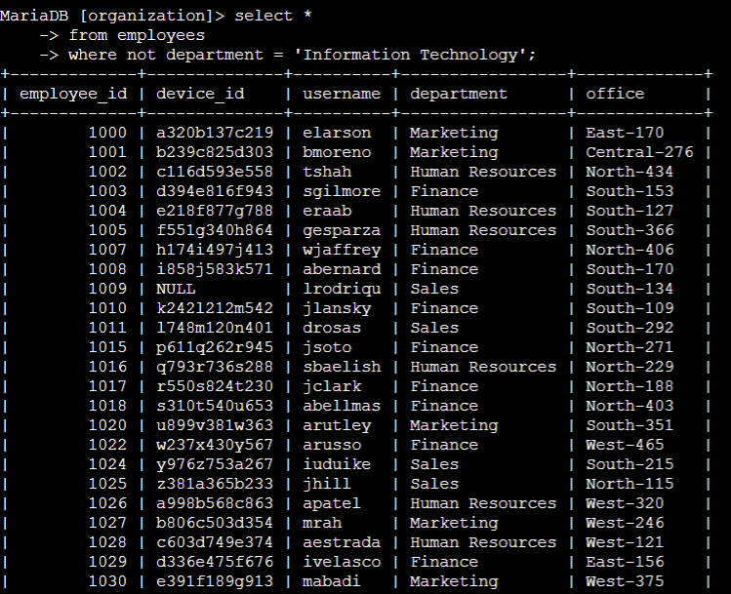

Filters data from employees table where department is not ‘Information Technology’.

## Summary

Many operators like ‘OR’, ‘AND’, and ‘NOT’ can be used to find specific data more conveniently. SQL makes it possible to find unwanted login attempts on our company’s logs, and list employees who are of interest for a device update, or other reasons.